Assignment - 1

T Godwin Abilash – 192321012

1. Two Sum

**Code:**

class Solution(object):

def twoSum(self, nums, target):

n=len(nums)

for i in range(n-1):

for j in range(i+1,n):

if nums[i]+nums[j]==target:

return[i,j]

**Screenshot:**

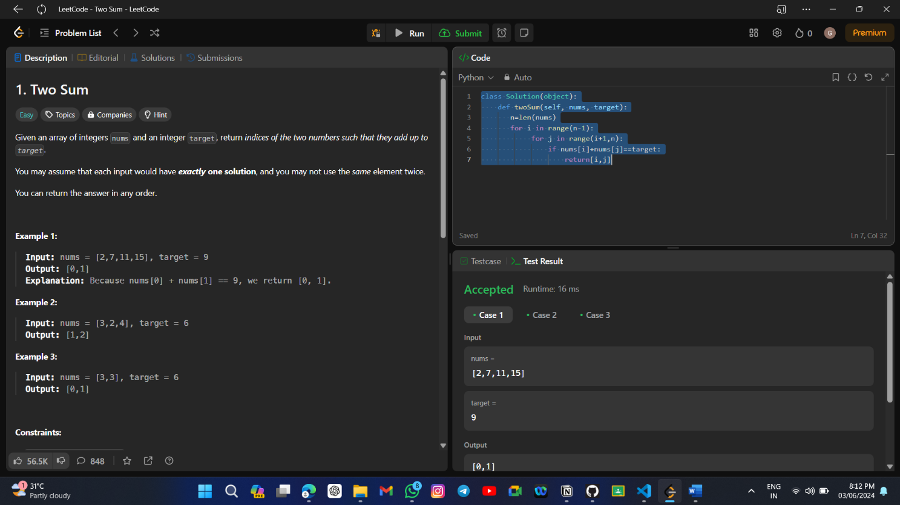

**Time Complexity:** O(n)

2. Two Sum

**Code:**

class Solution:

def addTwoNumbers(self, l1: Optional[ListNode], l2: Optional[ListNode]) -> Optional[ListNode]:

dummyhead=ListNode(0)

tail=dummyhead

carry=0

while l1 is not None or l2 is not None or carry !=0:

d1=l1.val if l1 is not None else 0

d2=l2.val if l2 is not None else 0

sum=d1+d2+carry

digit=sum%10

carry=sum//10

newnode=ListNode(digit)

tail.next=newnode

tail=tail.next

l1=l1.next if l1 is not None else None

l2=l2.next if l2 is not None else None

result=dummyhead.next

dummyhead.next=None

return result

**Screenshot for I/O:**

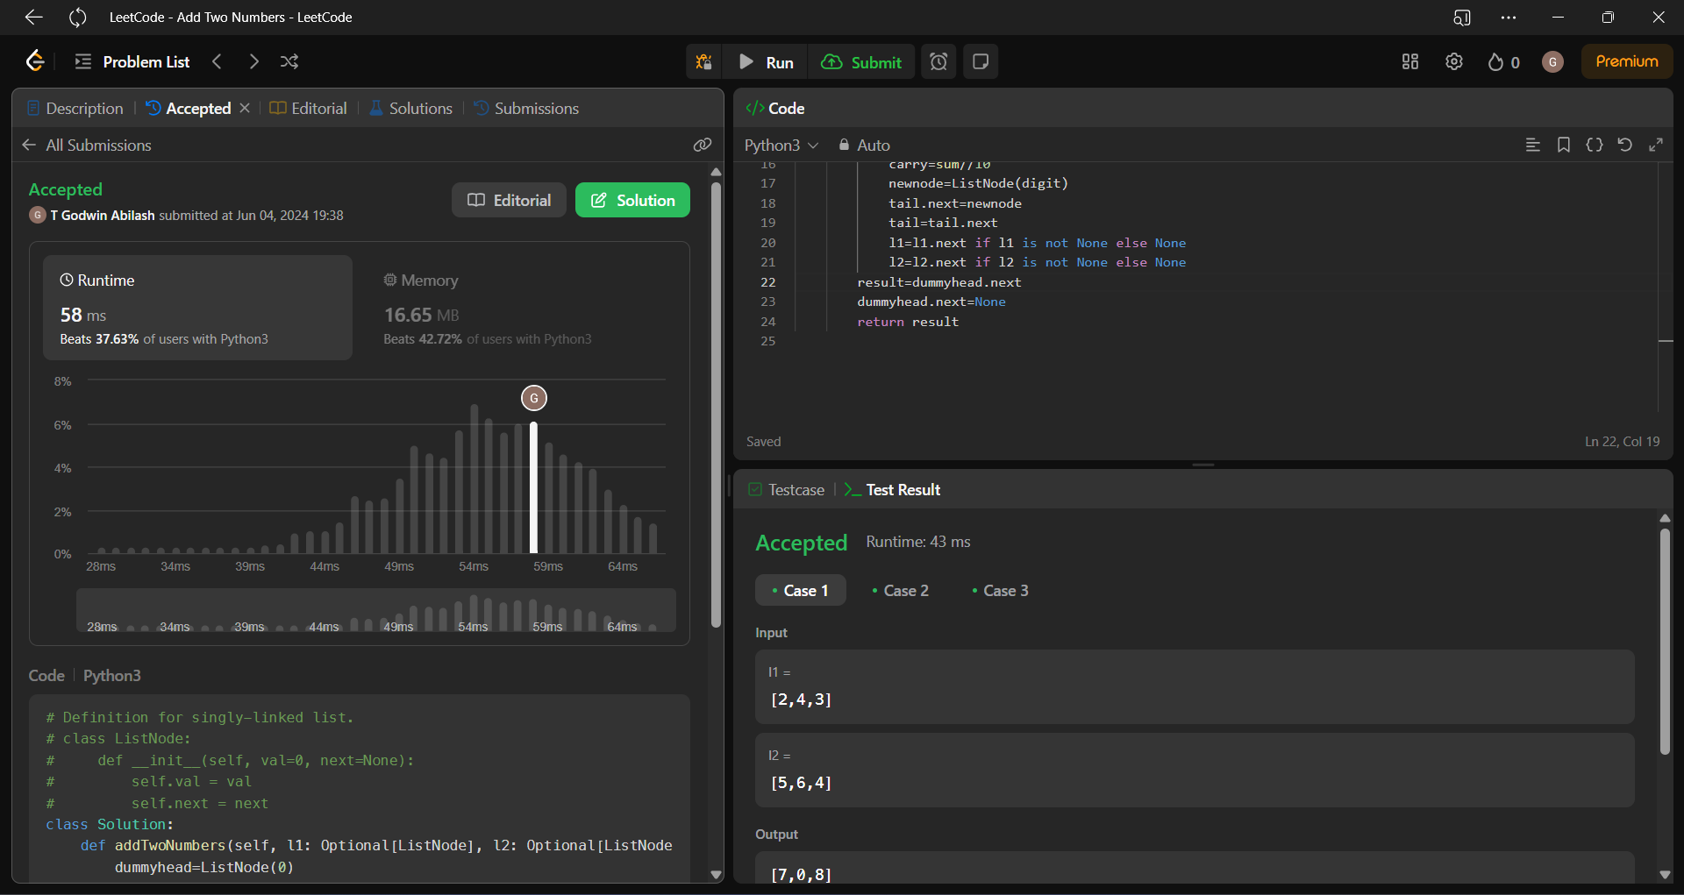

**Time Complexity:** O(max(m,n))

3. Longest Substring Without Repeating Characters:

**Code:**

class Solution:

def lengthOfLongestSubstring(self, s: str) -> int:

n = len(s)

maxLength = 0

charSet = set()

left = 0

for right in range(n):

if s[right] not in charSet:

charSet.add(s[right])

maxLength = max(maxLength, right - left + 1)

else:

while s[right] in charSet:

charSet.remove(s[left])

left += 1

charSet.add(s[right])

return maxLength

**Screenshot:**

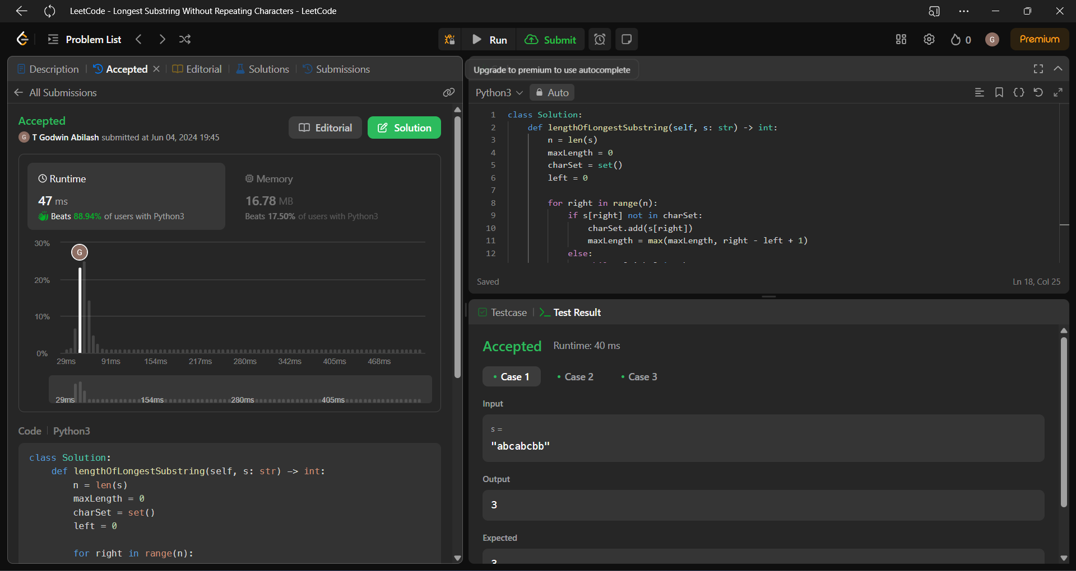

**Time Complexity: O(n)**

4. Median of Two Sorted Arrays

**Code:**

class Solution:

def findMedianSortedArrays(self, nums1, nums2):

merged = nums1 + nums2

merged.sort()

total = len(merged)

if total % 2 == 1:

return float(merged[total // 2])

else:

middle1 = merged[total // 2 - 1]

middle2 = merged[total // 2]

return (float(middle1) + float(middle2)) / 2.0

**Screenshot:**

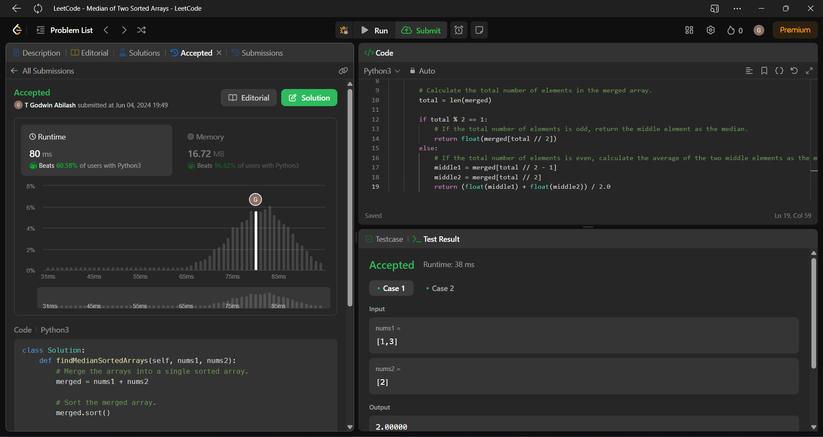

**Time Complexity: O(n)**

5. Longest Palindrome Substring

**Code:**

class Solution:

def longestPalindrome(self, s: str) -> str:

if len(s) <= 1:

return s

Max_Len=1

Max_Str=s[0]

for i in range(len(s)-1):

for j in range(i+1,len(s)):

if j-i+1 > Max_Len and s[i:j+1] == s[i:j+1][::-1]:

Max_Len = j-i+1

Max_Str = s[i:j+1]

return Max_Str

**Screenshot:**

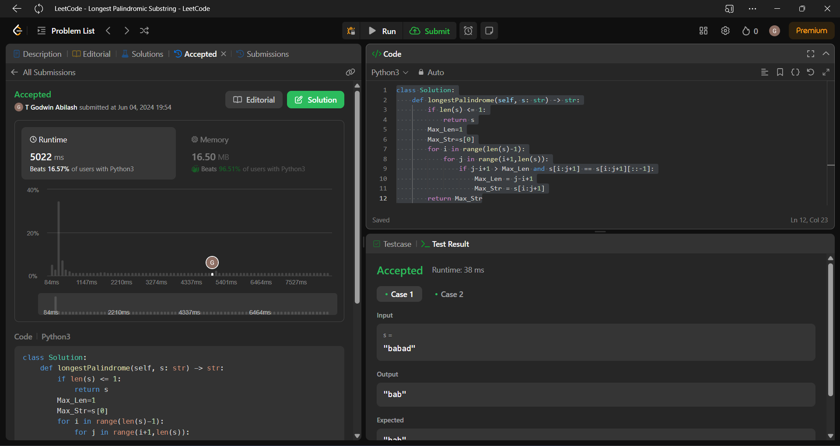

**Time Complexity: O(n2)**

6. Zigzag Conversion

**Code:**

class Solution:

def convert(self, s: str, numRows: int) -> str:

if numRows == 1:

return s

rows = [""] * numRows

add = 0

inc = 1

for i in s:

rows[add] += i

if add == 0:

inc = 1

elif add == numRows - 1:

inc = -1

add += inc

return "".join(rows)

**Screenshot:**

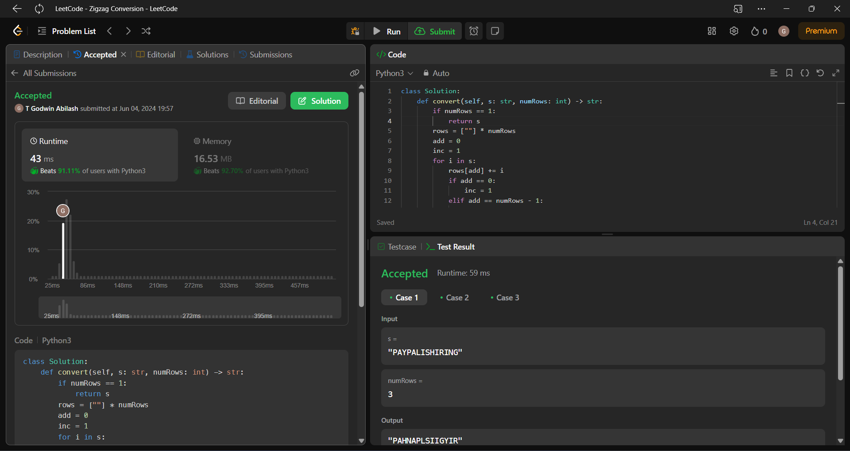

**Time Complexity: O(n)**

7. Reverse Integer

**Code:**

class Solution:

def reverse(self, x: int) -> int:

MAX_INT = 2 ** 31 - 1

MIN_INT = -2 ** 31

reverse = 0

while x != 0:

if reverse > MAX_INT / 10 or reverse < MIN_INT / 10:

return 0

digit = x % 10 if x > 0 else x % -10

reverse = reverse * 10 + digit

x = math.trunc(x / 10)

return reverse

**Screenshot:**

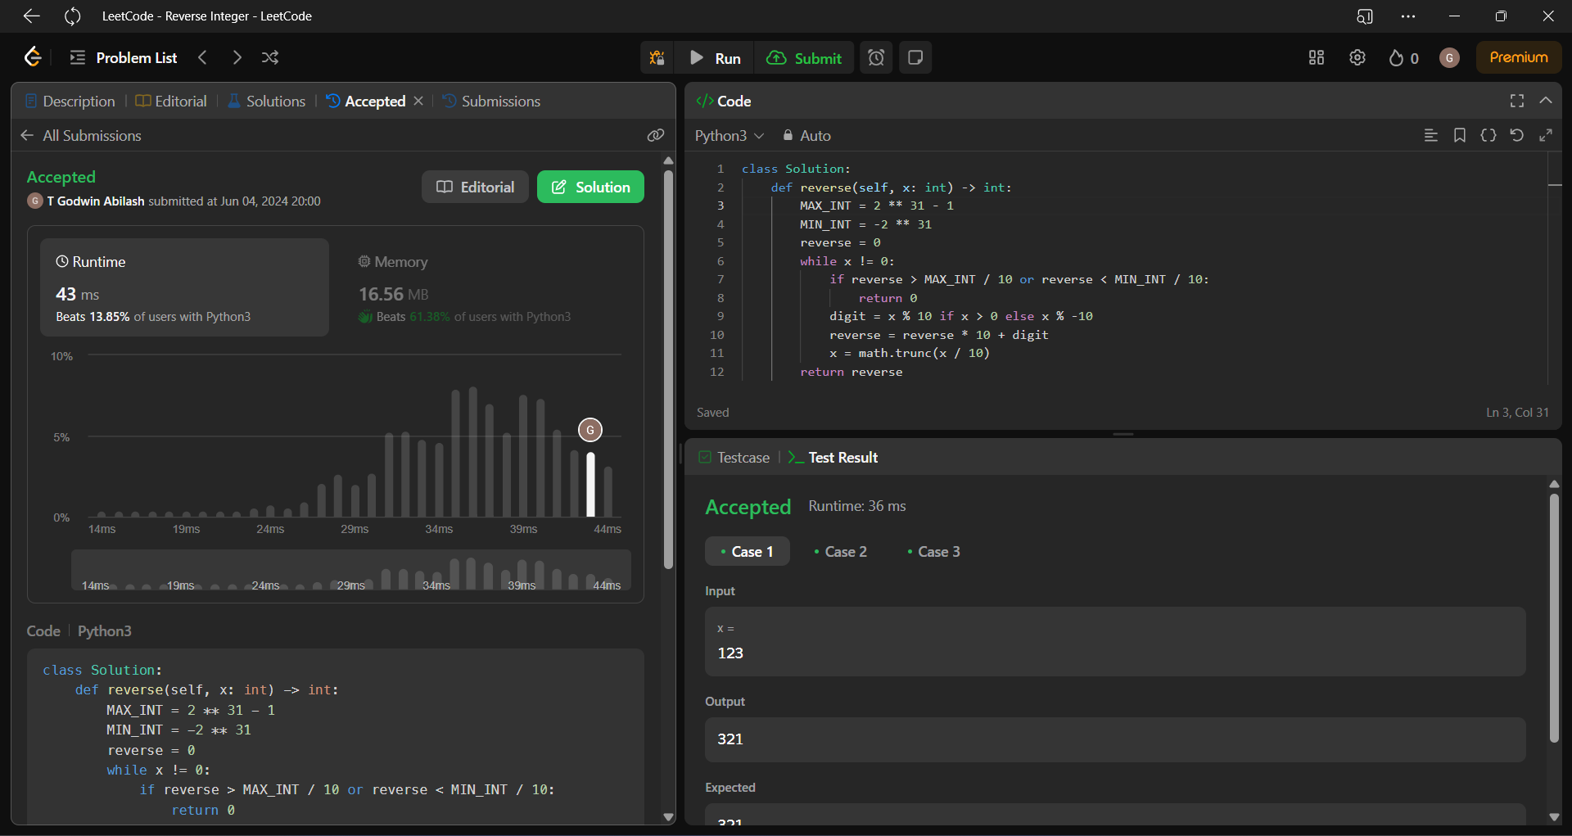

**Time Complexity: O(n)**

8. String to Integer (atoi)

**Code:**

class Solution(object):

def myAtoi(self, s):

num = '0123456789'

res = ''

for x in s:

if x == ' ' and len(res) == 0:

continue

if x != ' ' and (x in '-+' or x in num) and len(res) == 0:

res += x

elif x in num:

res += x

else:

break

if res == '' or res in '-+':

return 0

else:

if int(res) < -(2**31):

return -(2**31)

elif int(res) > (2**31 - 1):

return (2**31 - 1)

else:

return int(res)

**Screenshot:**

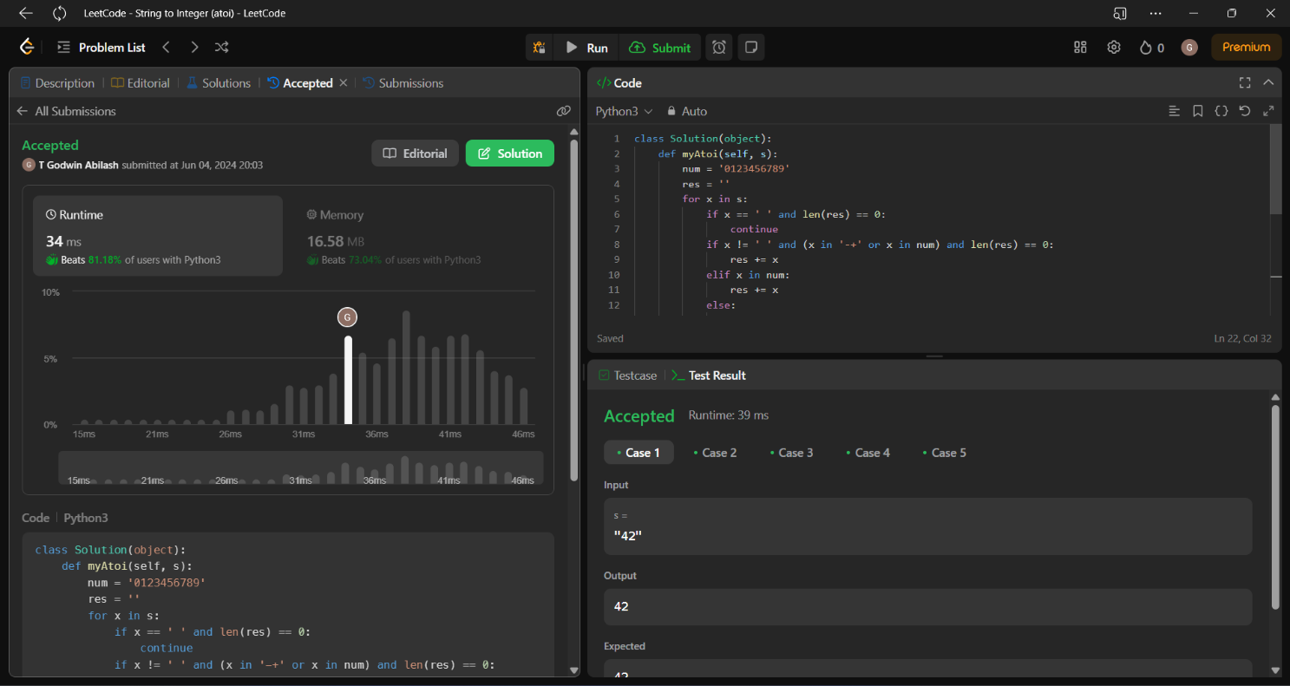

**Time Complexity: O(n)**

9. Palindrome Number

**Code:**

class Solution:

def isPalindrome(self, x: int) -> bool:

if x < 0:

return False

reverse = 0

xcopy = x

while x > 0:

reverse = (reverse * 10) + (x % 10)

x //= 10

return reverse == xcopy

**Screenshot:**

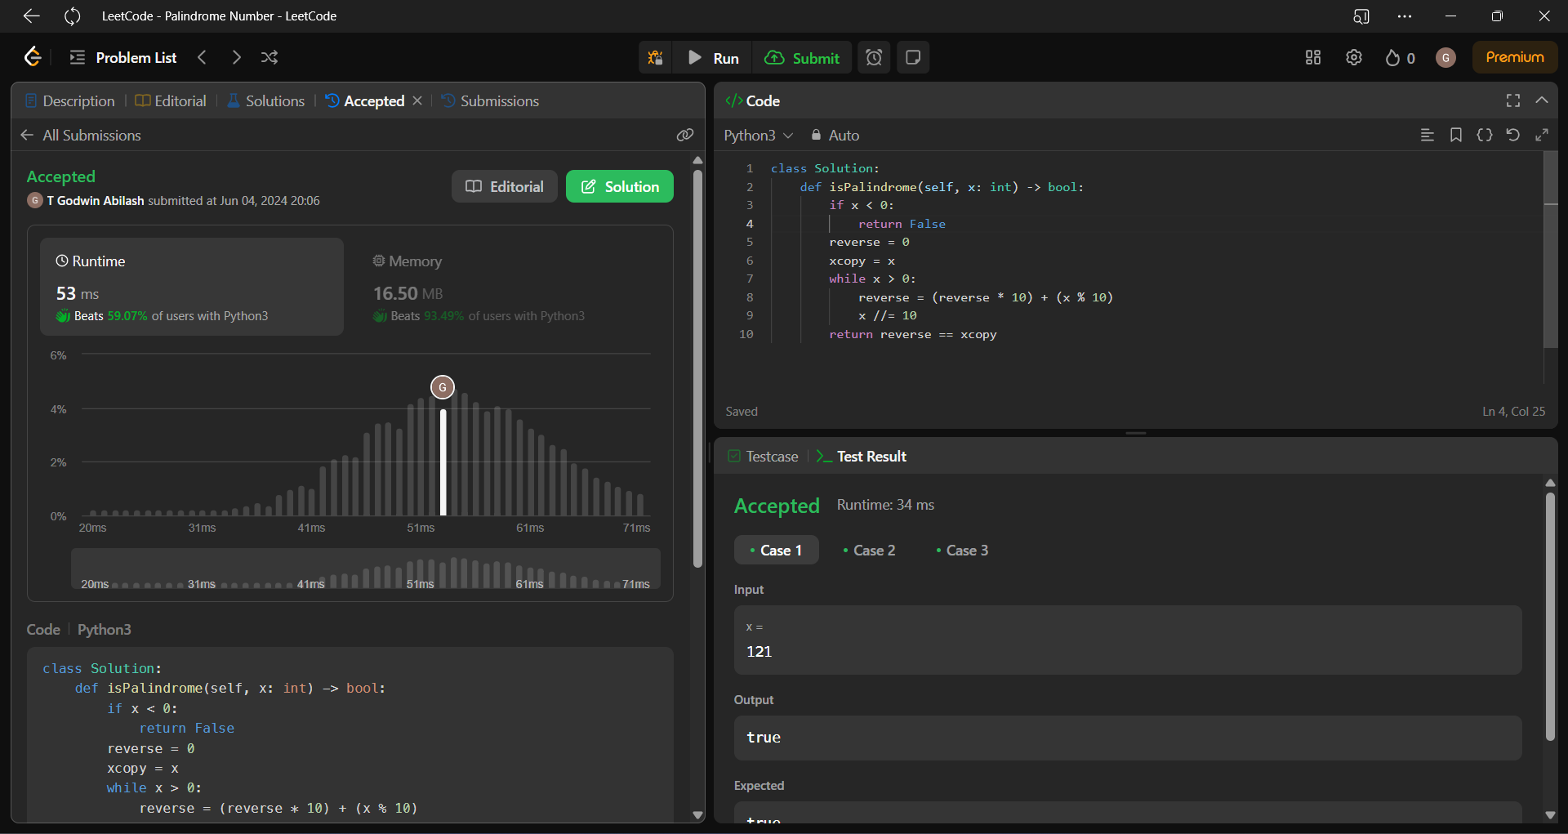

**Time Complexity: O(logn)**

10. Regular Expression Matching

**Code:**

class Solution:

def isMatch(self,s: str, p: str) -> bool:

m, n = len(s), len(p)

dp = [[False] * (n + 1) for _ in range(m + 1)]

dp[0][0] = True

for j in range(1, n + 1):

if p[j - 1] == '*':

dp[0][j] = dp[0][j - 2]

for i in range(1, m + 1):

for j in range(1, n + 1):

if p[j - 1] == '.' or p[j - 1] == s[i - 1]:

dp[i][j] = dp[i - 1][j - 1]

elif p[j - 1] == '*':

dp[i][j] = dp[i][j - 2]

if p[j - 2] == '.' or p[j - 2] == s[i - 1]:

dp[i][j] = dp[i][j] or dp[i - 1][j]

return dp[m][n]

**Screenshot:**

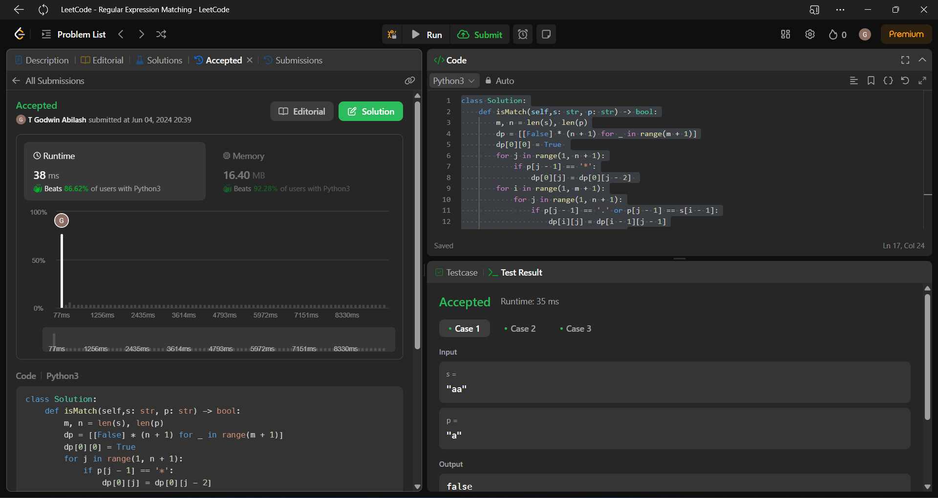

**Time Complexity: O(m*n)**